LABORATORY #2

COMPFP1 10:10AM - 12:50PM MWF

MAY 19, 2025

zaa

CADWISING,ZACKARY TROY B.

zaa

**What is World Processing?**

Word processing is using a computer to create, edit, format, store and print documents such as letters and reports using a word processor. This document app application tool enables the user to create document, display it on the computer screen, display it on the computer screen, save it on the disk print it using a printer attached to the computer hardware.

|  |  |  |
| --- | --- | --- |
| **Advantages**   * Allows easy updating and correction * Allows automatic insertion of text * Transmission of document | **Key new feature in Mircrosoft Word XP**   * Speech and handwriting recognition * Web documents and Web sites * Language-specific features |  |

The following are the basic features of word processors, which also function as text editors:

1. **Page size and margins** allows you to define various page sizes and margins, and the word processor will automatically readjust the text so that it fits.
2. **Search and replace** allows you to direct the word processor to search for a particular word or phrase. You can also direct the word processor to replace one group of characters with another everywhere that the first group appears.

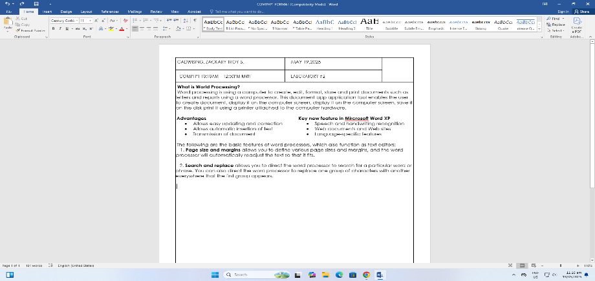

**1**

**2**

|  |  |
| --- | --- |
| 1. Title Bar | Displays the name of the application (MS Word) and/or the name of the active document. |
| 2. Title Bar Icon | Controls the application window or the document window |
| 3. Ruler | Sets tab stops and indents for paragraphs |
| 4. Insertion Point/Cursor | Indicates where you can type text or insert object. |
| 5. Document/Text Window | Window It is where all the texts and objects are placed. |
| 6. View Buttons | Located at the left of the horizontal scroll bar that view your work in 4 different ways. |
| 7.Drawing Buttons | Contains icons that allow you insert clip art, diagram, textbox, picture, line, among others. |
| 8. Status Bar | Displays information about the document such as page number, number of pages, current line and column number. |
| 9. Minimize Buttons | Reduces the window to an icon. |
| 10. Restore/Maximize Button | Restores the window to its previous size and location. |
| 11. Close Button | Closes the window. |
| 12. Menu Bar | Displays the different menus (File, Edit, View, Insert, Format, Tools, Tables, Window, and Help). A Menu is made up of several commands. |
| 13. Toolbar | Provides quick access to frequently used commands |
| 14. Scroll Bars | Use the vertical and horizontal scroll bars to move around the document. |

**STABILITY CONSTANT AT 25°C**

|  |  |  |  |
| --- | --- | --- | --- |
| **LIGAND** | **METAL ION** | **COMPLEXION** | **STABILITY CONSTANT, K** |
| Ammonia, NH | Cadmium | Cd(NH3) 4 2+ | 1.3 x 107 |
|  | Cobalt | Co(NH3) 6 2+ | 1.3 x 105 |

H4SiO4 + 4NaOH 1 Na4S

The Following are the basic rules in addition of binary numbers:

|  |  |
| --- | --- |
| * 02 + 02 = 02 * 12 + 02 = 12 | * 02 + 12 = 12 * 12 + 12 = 102 |

|  |
| --- |
|  |